**MongoDB Sandbox (Atlas)**

Let create a sandbox for the MongoDB workshop

1. Go to <https://www.mongodb.com/cloud> and click on *‘Get started free’*

Click Here

1. Enter the details and click ‘Get started free’

1. Once registration is complete, you will see below page. Graphical user interface

   Description automatically generated
2. Select the “Starting at FREE” and click on create a cluster.

1. Select the Cloud provider and the region

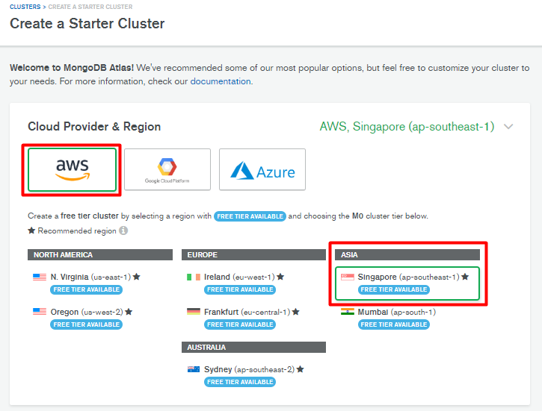

1. Scroll-down & Check for ‘**free forever**’ pricing is selected

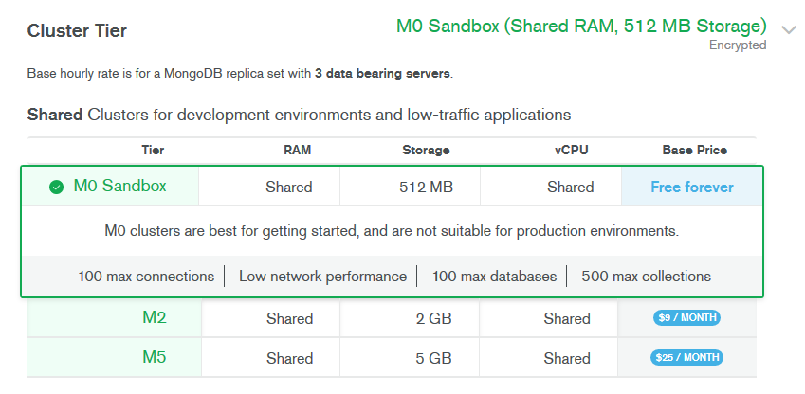

1. Scroll-down and Give a name to your cluster and click ‘*Create Cluster’*

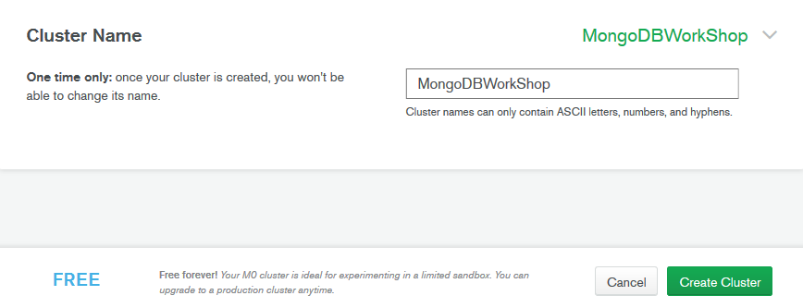

1. It will take around 7-10 minutes to create the cluster for you…Wait for it

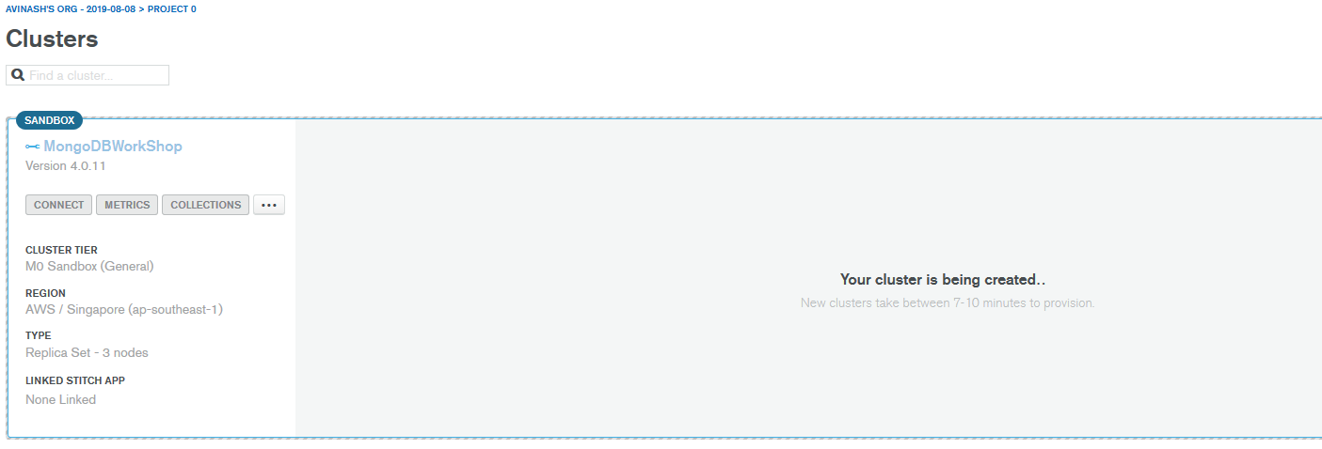

1. Will look like this once cluster is up and running

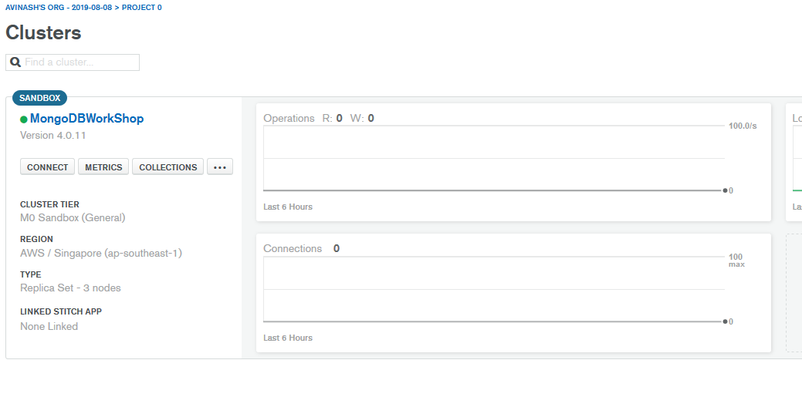

1. Now, setup an access to the cluster by doing below configuration. Go to ‘Network Access’ under ‘Security’

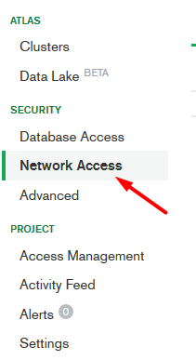

1. Under ‘IP Whitelist’, add your IP address by clicking

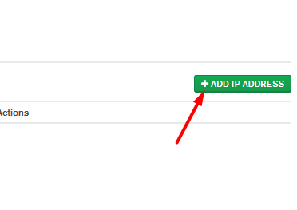

1. Click on ‘ALLOW ACCESS FROM ANYWHERE’ and then ‘Confirm’. Wait for few second to see the status as ‘Active’

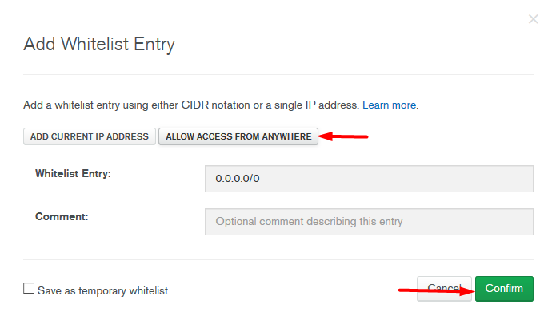

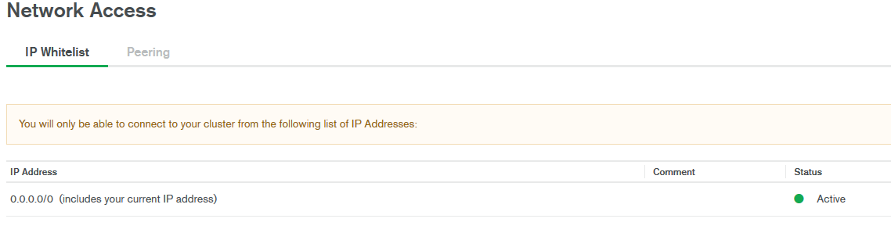

1. Let’s create a user to access the cluster. Click on ‘Database Access’ and then on ‘ADD NEW USER’

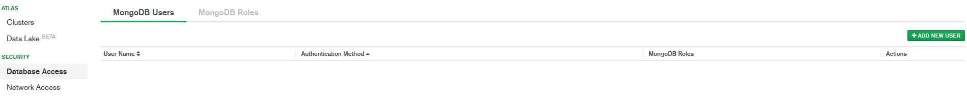

1. Select ‘Atlas Admin’ and provide username and password and click on ‘Add user’ to see the entry.

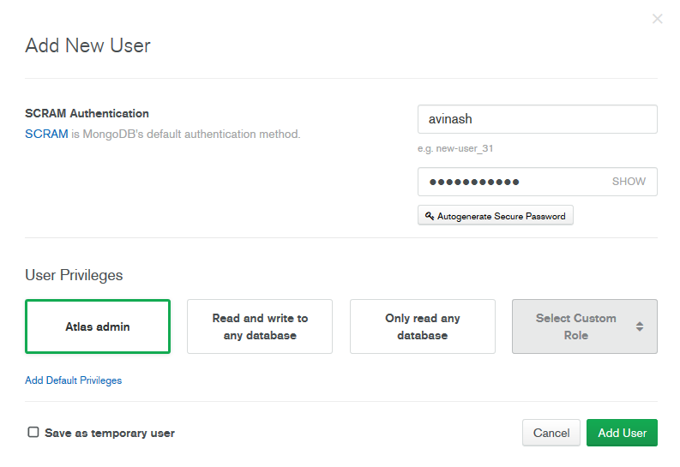

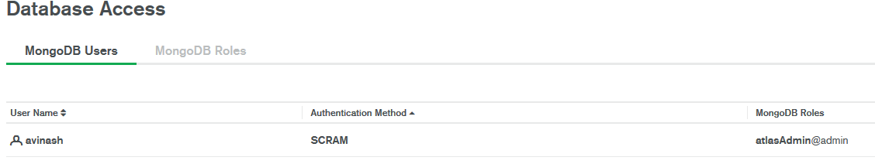

**Cluster is ready to use. Let’s load some data and play around with it.**